Introduction to Computer Vision (Lecture 1)

Slide 1: Course Title
Introduction to Computer Vision

Lecture 1: History, Challenges, and Modern Advancements
Slide 2: What is Computer Vision?
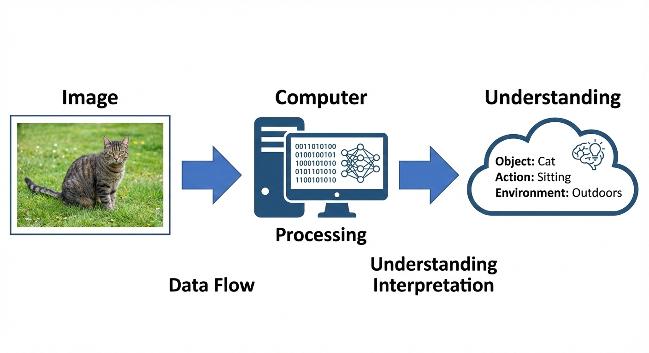
- Computer Vision enables machines to see, interpret, and understand images and videos
- Core goal: Convert visual data (pixels) into meaningful information
- Interdisciplinary field: AI, Machine Learning, Mathematics, Neuroscience

Slide 3: Human Vision vs Computer Vision
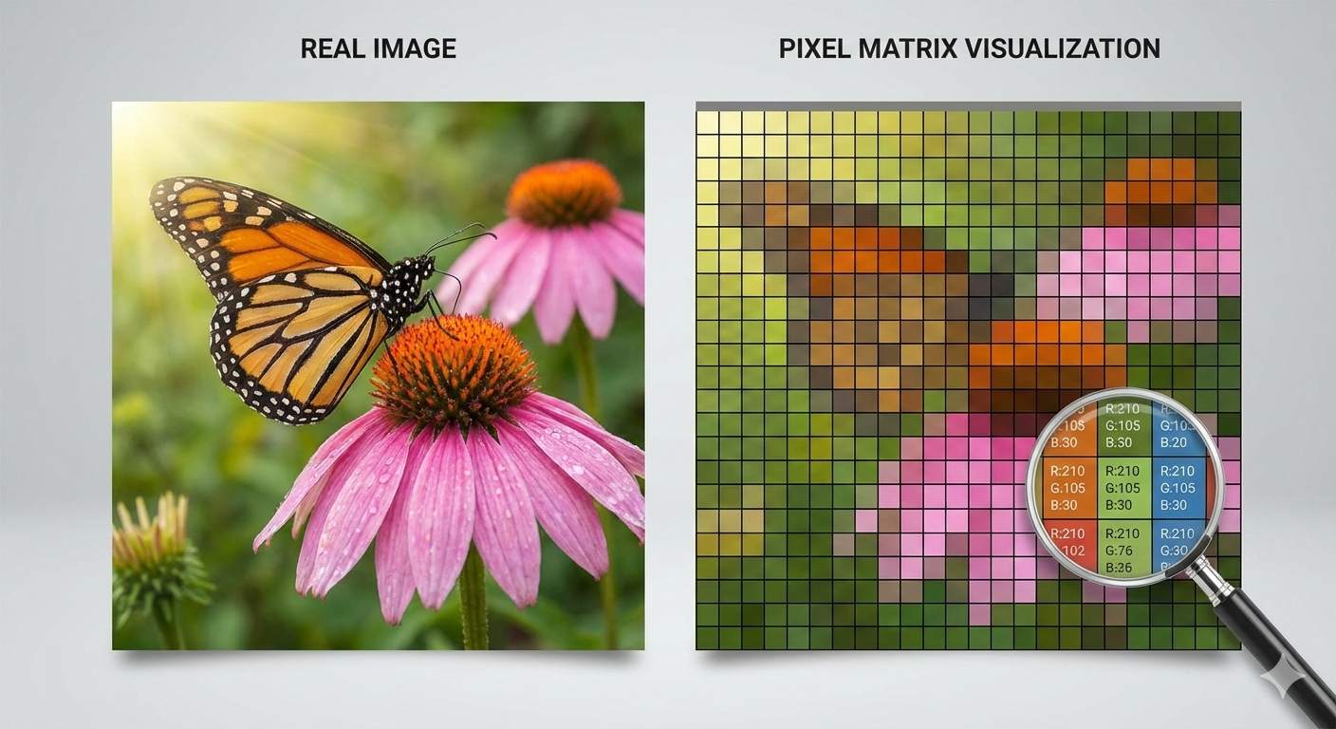
- Humans instantly recognize objects, scenes, and actions
- Computers only see numerical pixel values
- An image = matrix of numbers (height × width × channels)
Example: - Human: “This is a dog in a park” - Computer: RGB pixel intensities

Slide 4: Why is Computer Vision Difficult?
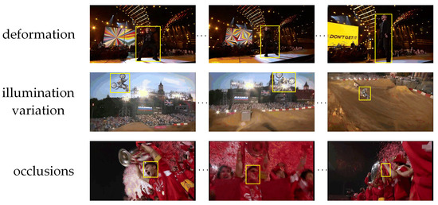
Key challenges: - Viewpoint variation - Illumination changes - Occlusion (partial visibility) - Background clutter - Deformation of objects

Slide 5: Viewpoint & Illumination Variations

- Same object looks different from different angles
- Lighting drastically changes pixel values
Example: - Car photographed from front vs side - Same street image: day vs night

Slide 6: Occlusion & Background Clutter
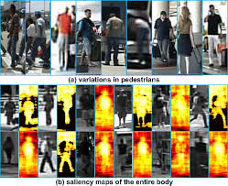
- Objects may be partially hidden
- Objects blend with complex backgrounds
Example: - Pedestrian behind a car - Animal camouflaged in environment

Slide 7: Early History of Computer Vision (1960s)
- Early belief: vision is easy and can be solved quickly
- Reality: visual understanding is extremely complex

Slide 8: Traditional Computer Vision Era (1970s–1990s)
- Manually designed features
- Rule-based systems
- Limited generalization

Slide 9: Hand-Crafted Features

Common techniques: - Edge detection - Corner detection - Texture analysis

Slide 10: Classical Algorithms
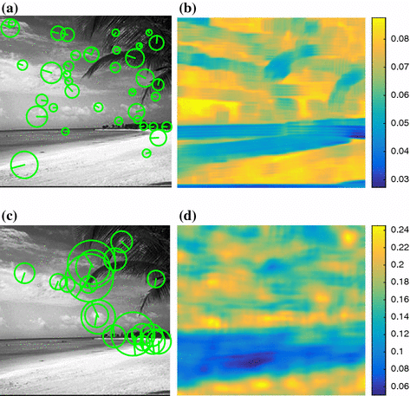
- Canny Edge Detector
- SIFT (Scale-Invariant Feature Transform)
- HOG (Histogram of Oriented Gradients)
Limitation: Features designed by humans

Slide 11: Biological Inspiration
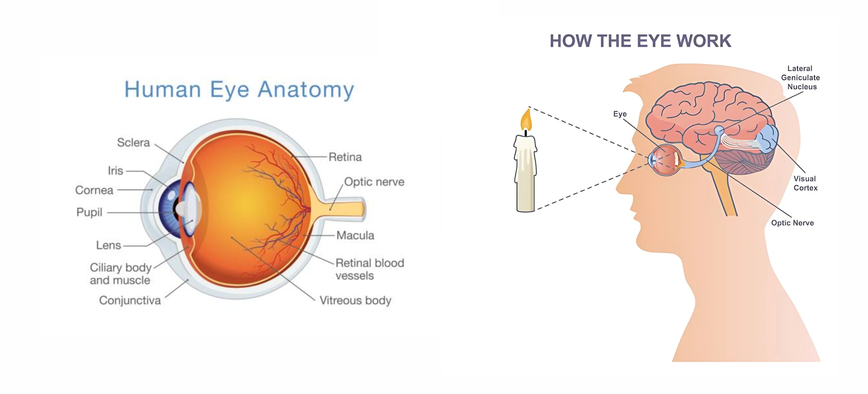
- Visual system processes information hierarchically
- Simple patterns → complex structures

Slide 12: Hubel & Wiesel Experiments
- Studied neurons in visual cortex
- Found neurons respond to:
  - Edges
  - Orientations
  - Patterns

Slide 13: Key Insight from Biology
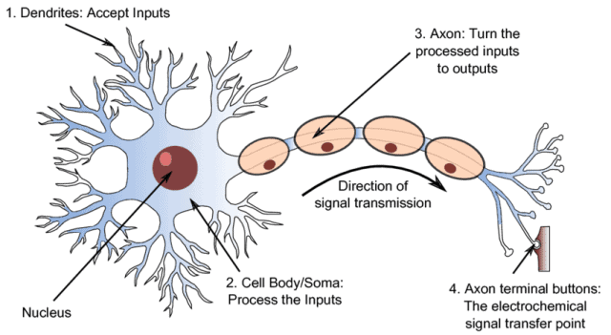
- Vision works in layers
- Inspired layered neural network architectures
- Foundation of Convolutional Neural Networks (CNNs)

Slide 14: Traditional Vision Pipeline
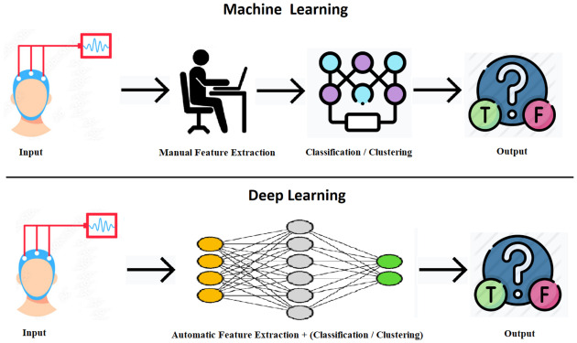
Pipeline: Image → Feature Extraction → Classifier → Output
Problems: - Manual feature design - Poor scalability

Slide 15: Deep Learning Revolution
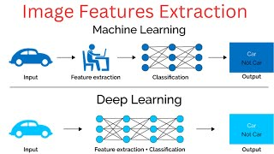
- Features learned automatically from data
- End-to-end learning
Pipeline: Image → Neural Network → Output

Slide 16: Neural Networks in Vision
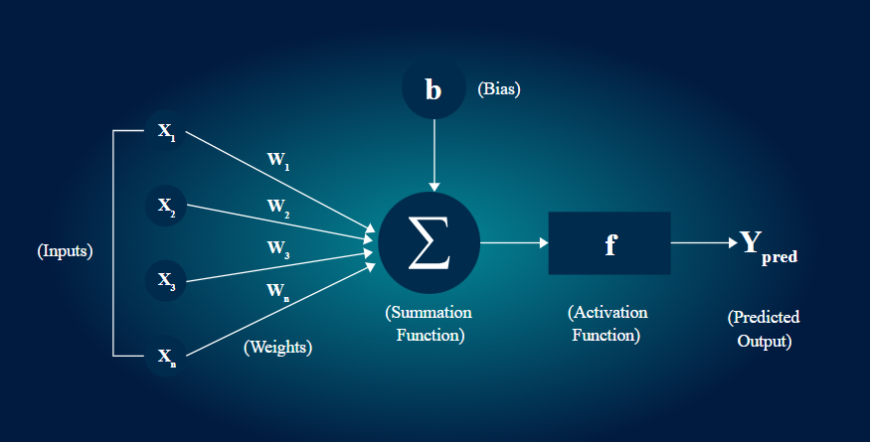
- Multiple layers
- Each layer learns higher-level features
- Uses backpropagation for learning

Slide 17: The ImageNet Dataset
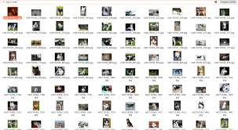
- Millions of labeled images
- 1000 object categories
- Standard benchmark for vision models

Slide 18: AlexNet Breakthrough (2012)
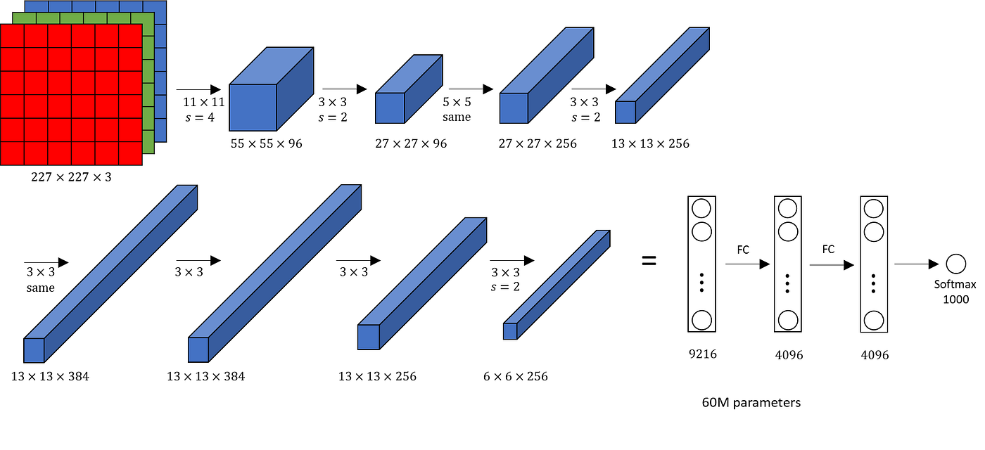
- Deep CNN trained on ImageNet
- Massive accuracy improvement
- Triggered deep learning revolution

Slide 19: Why AlexNet Worked
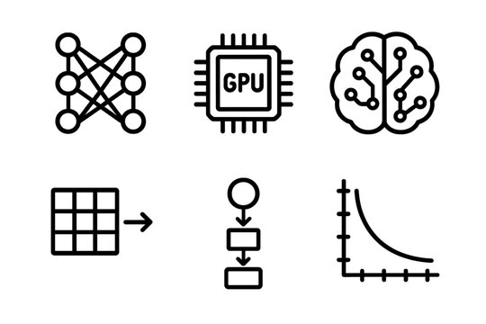
- Large dataset
- GPU acceleration
- Deep architectures
- Efficient training (ReLU, dropout)

Slide 20: Modern Computer Vision Capabilities
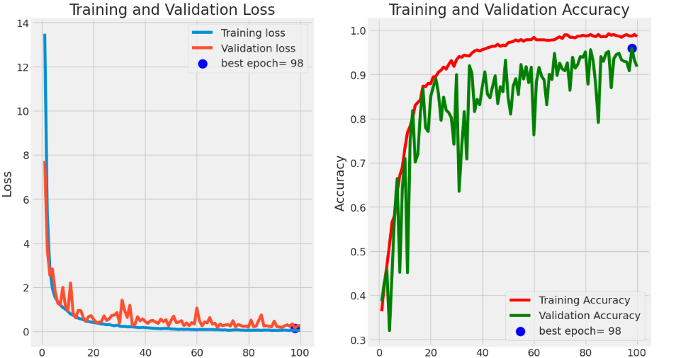
- High accuracy on complex tasks
- Scales with data and compute
- Deployed in real-world systems

Slide 21: Core Vision Tasks
- Image Classification
- Object Detection
- Semantic Segmentation
- Instance Segmentation

Slide 22: Image Classification
- Assign a single label to an image
Example: Image → “Cat”

Slide 23: Object Detection
- Locate and classify multiple objects
- Uses bounding boxes
Example: Car, Person, Bicycle

Slide 24: Semantic Segmentation
- Classify each pixel
- All objects of same class share label

Slide 25: Instance Segmentation
- Separates individual object instances
- Pixel-level precision

Slide 26: Image Captioning
- Generate natural language description
Example: “A person riding a bicycle on the road”

Slide 27: Real-World Applications
- Autonomous driving
- Medical image analysis
- Face recognition
- Surveillance systems

Slide 28: More Applications
- Satellite imagery
- Robotics
- Augmented reality
- Industrial inspection

Slide 29: Tools & Frameworks
- Python
- NumPy
- PyTorch / TensorFlow
- GPU acceleration

Slide 30: Learning Philosophy
- Learn by implementation
- Focus on fundamentals
- Strong mathematical foundation

Slide 31: Limitations of Computer Vision
- Sensitive to data bias
- Poor generalization in unseen cases
- Lack of reasoning and common sense

Slide 32: Ethical Considerations
- Bias in face recognition
- Privacy concerns
- Responsible AI usage

Slide 33: Open Research Challenges
- Robustness
- Interpretability
- Multimodal learning
- Low-data learning

Slide 34: Future Directions
- Generative vision models
- Vision-language models
- Human-centered AI

Slide 35: Key Takeaways
- Computer vision is challenging but impactful
- Deep learning transformed the field
- Many open problems remain

Slide 36: End of Lecture 1
Next Topics: - Image classification pipelines - k-NN and Linear classifiers

